# Overview

The red arm is the front/nose of the drone.

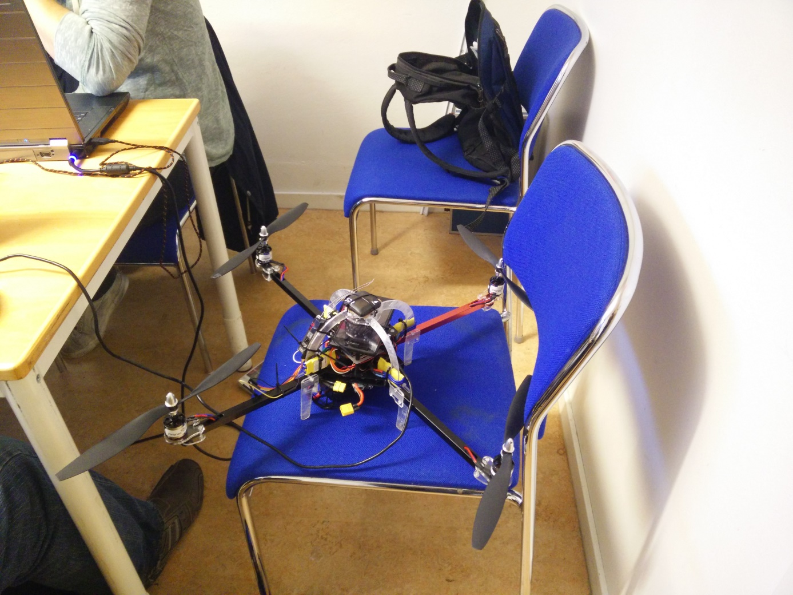

## Pixhawk wiring:

https://pixhawk.org/users/wiring

# Overview and battery connector

Only way to completely shut down the connector is to remove the battery connector.

From bottom:

* Battery
* Battery holder
* Main chassis plate
  + Power measurement circuit board
  + Speaker
* Power distribution board
* First shelf
  + Pixhawk
* Second shelf
  + Phone
* Rollhoop
  + Safety switch
  + Radio transmitter
  + GPS+Compass

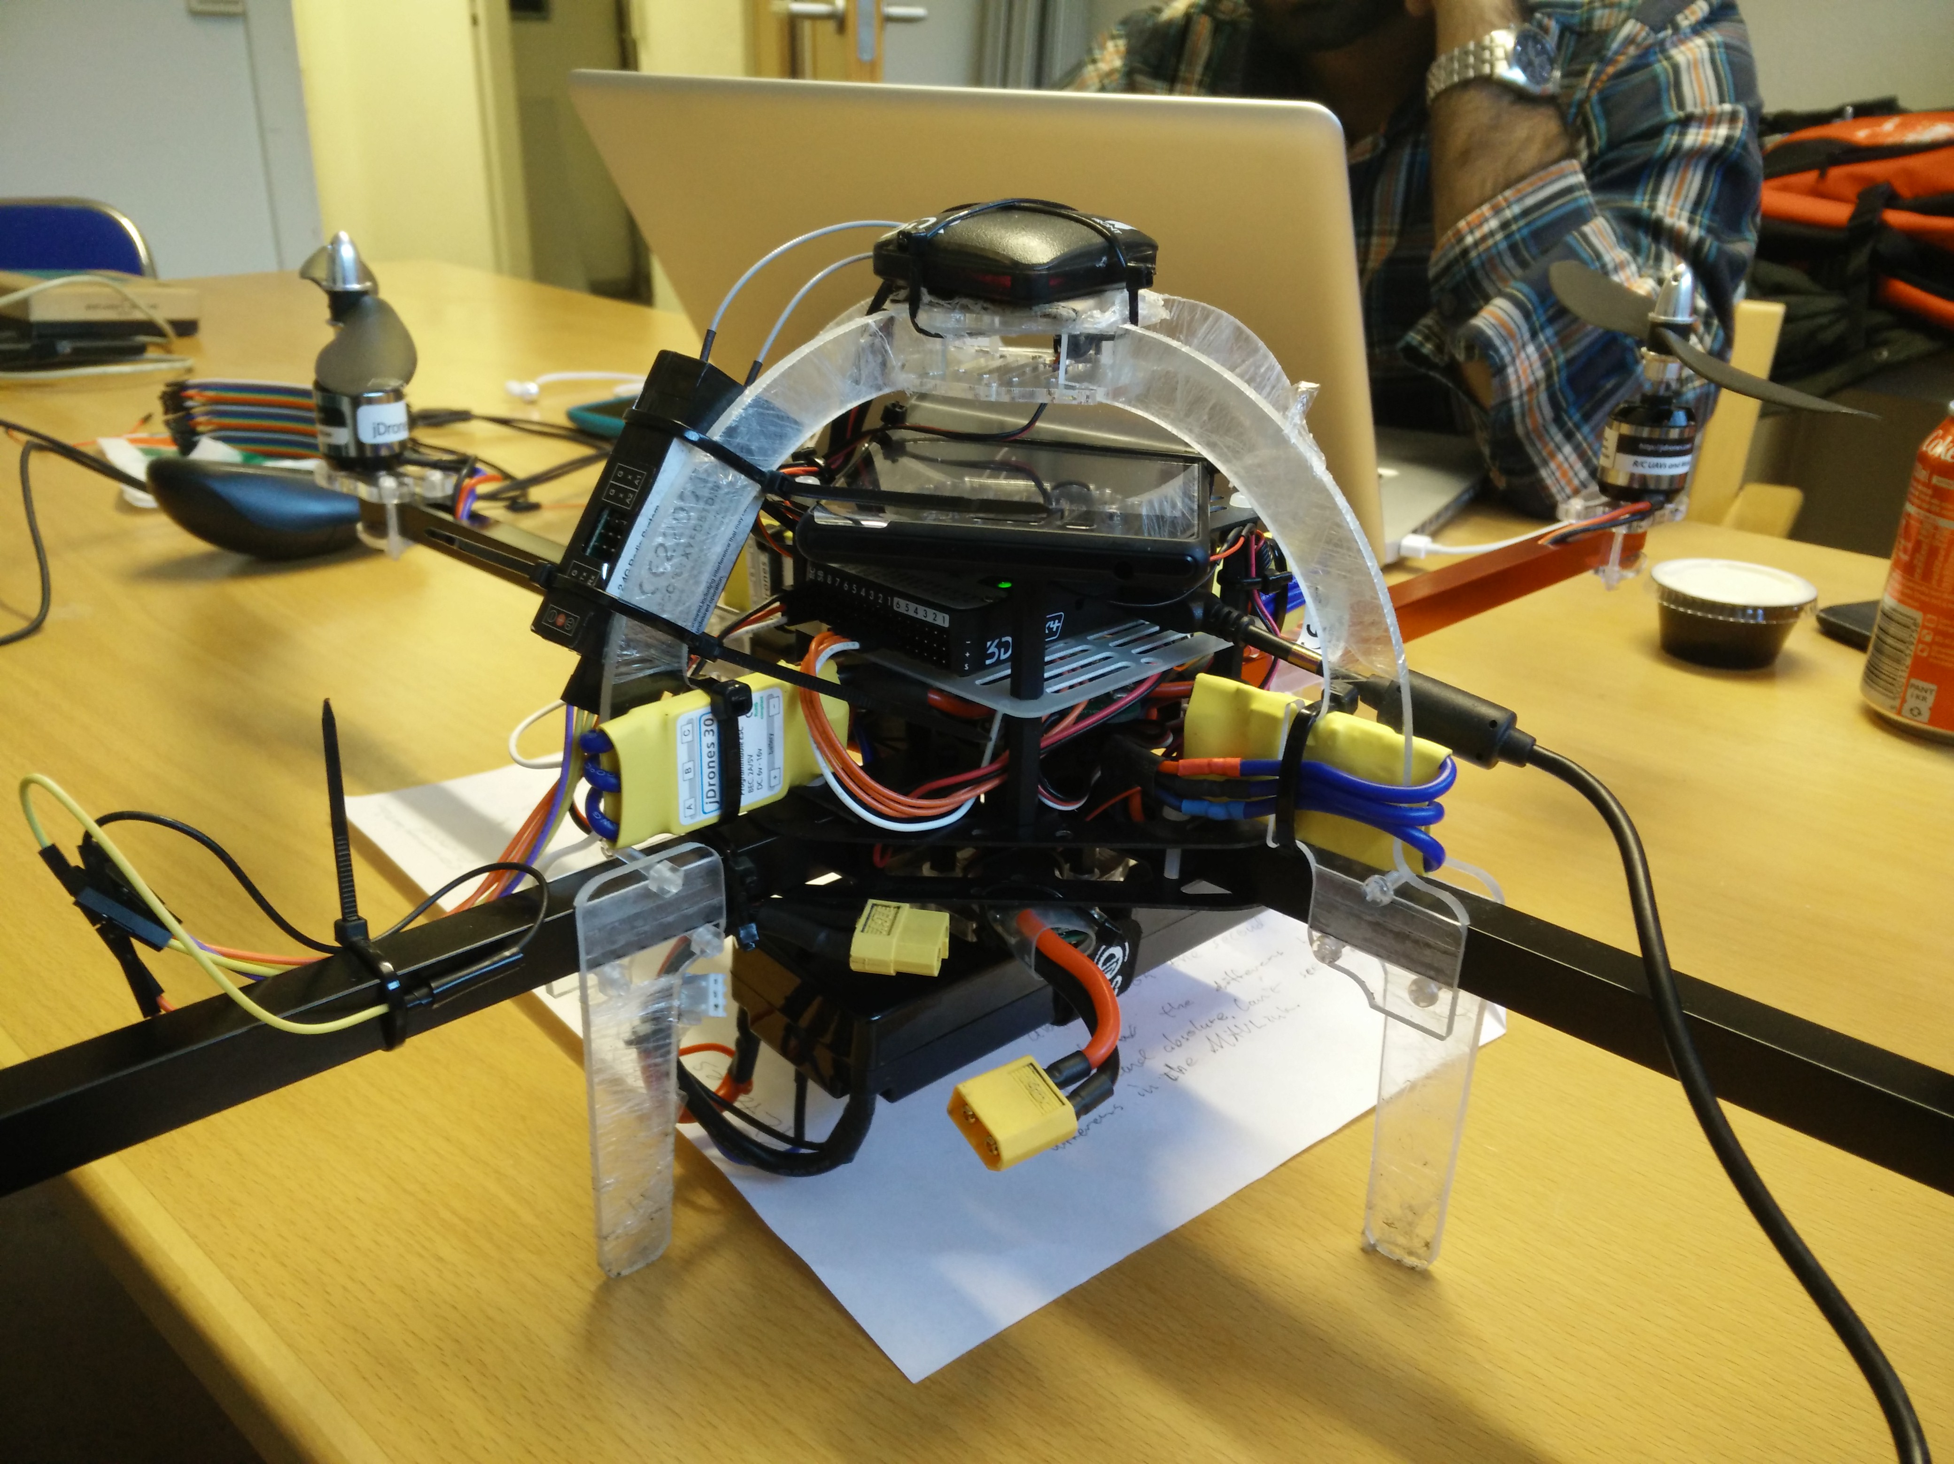

# Output and Radio connector

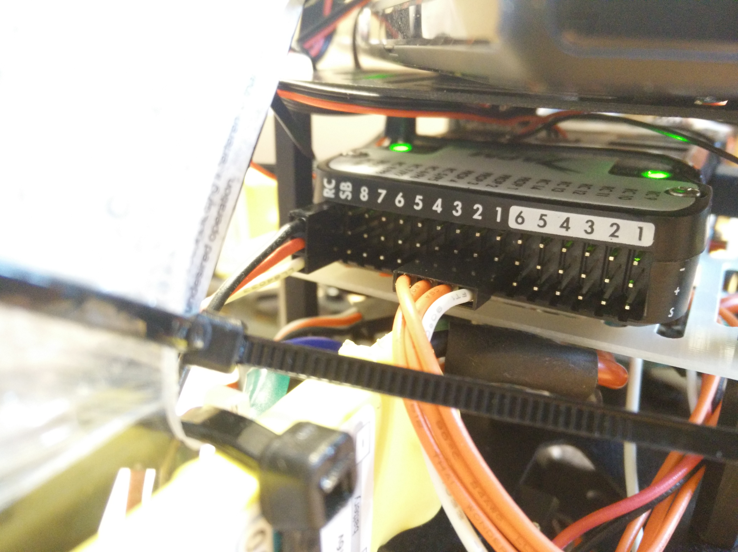

From bottom up:

* Signal
* Positive supply out
* Ground

From left to right:

Radio Connection

* PPM Radio Transmitter
* SB: NC

Main ESC output PWM

* 8
* 7
* 6

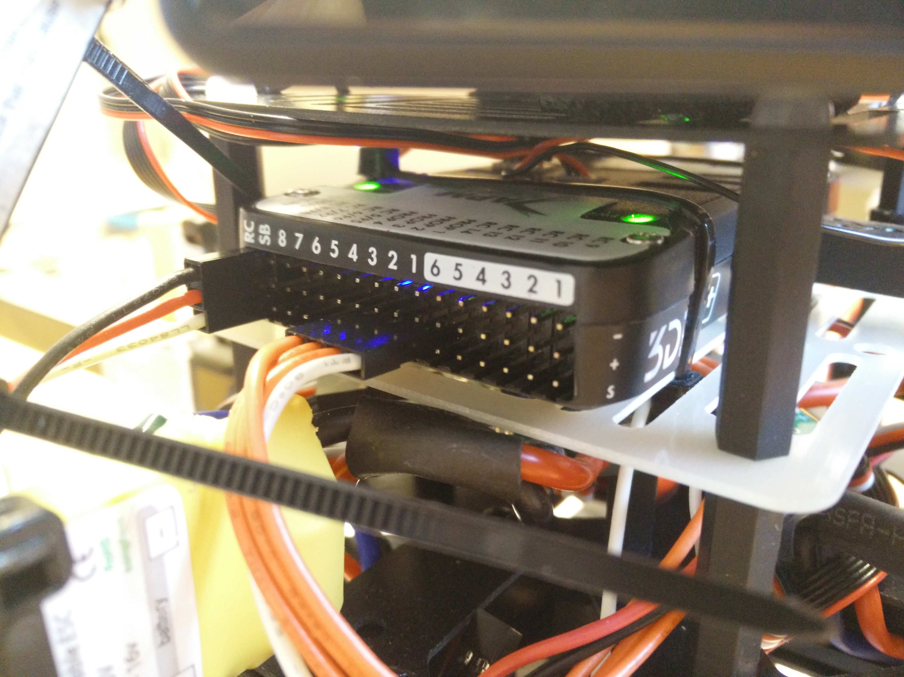

* 5
* 4: ESC 4
* 3: ESC 3
* 2: ESC 2
* 1: ESC 1

AUX output PWM

* 6
* 5
* 4
* 3
* 2
* 1

# GPS and compass

It’s important to place the sensor with the Arrow pointing in the same direction as the quadcopter nose.

GPS Left to right

* VCC
* RX
* TX
* NC
* NC
* GND

Compass

* 3.3V
* SCL
* SDA
* GND

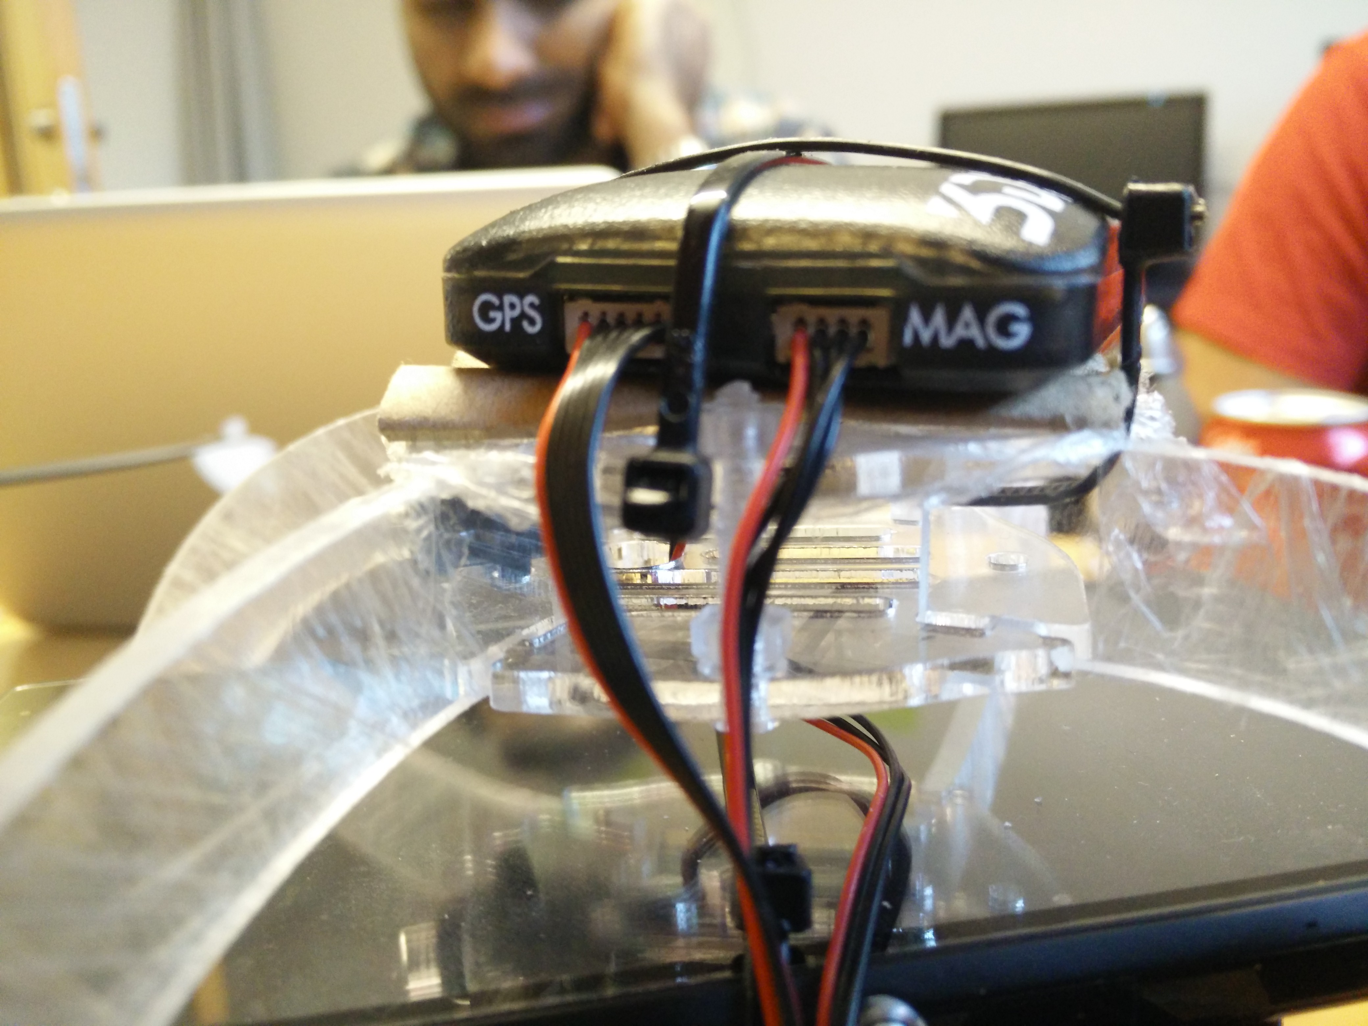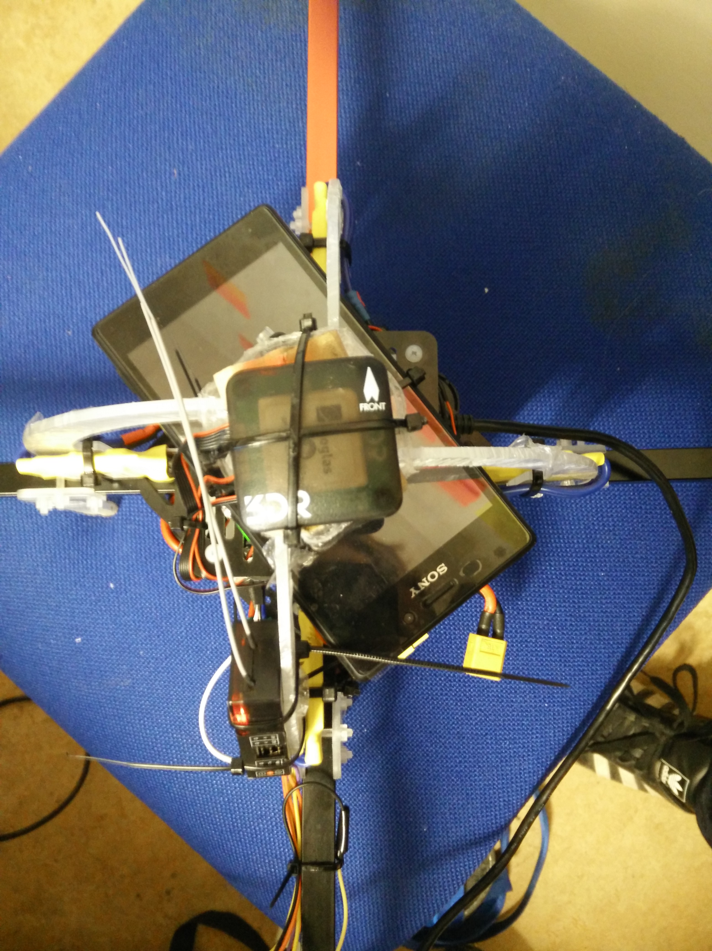

# Radio Transmitter

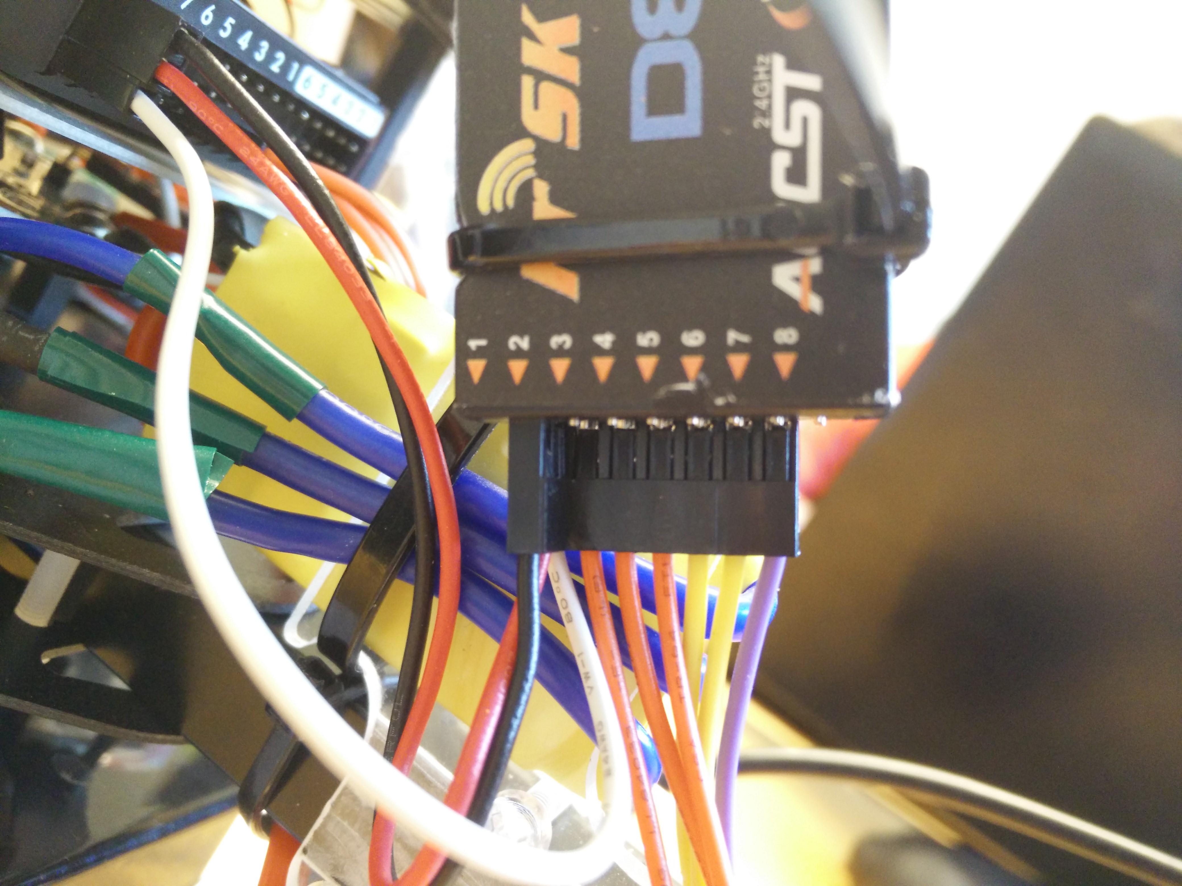

The Transmitter has been reflashed to another firmware that supports CPPM output.

http://www.rcgroups.com/forums/showthread.php?t=1866014#post24625982

From bottom up:

* Signal
* Positive supply in
* Ground

From left to right:

Output

* 1: CPPM Radio Transmitter
* 2: NC
* 3: Jumper to 4 for CPPM mode
* 4: Jumper to 3 for CPPM
* 5: NC
* 6: NC

Side

* Channel

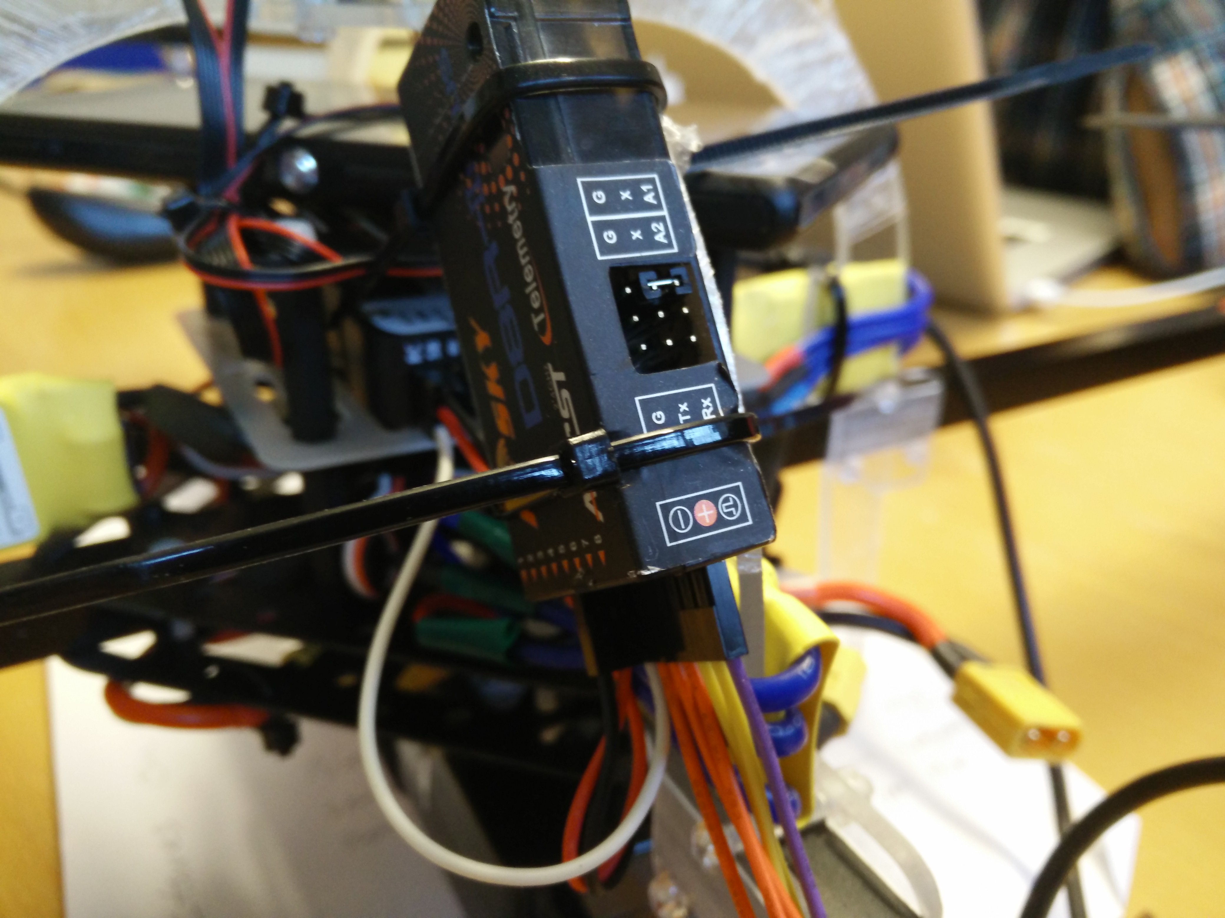

# DAQ

4GB micro-SD card that logs in a format similar to MAVlink. Use APM/Mission planner to download the data directly through the pixhawk.

